**Content**

1. Blockchain intuition 2

1. Decentralized vs Distributed 2

1. Blockchain intuition



Blockchain is a continuously growing list of record, called blocks, which are linked and secured cryptographically.

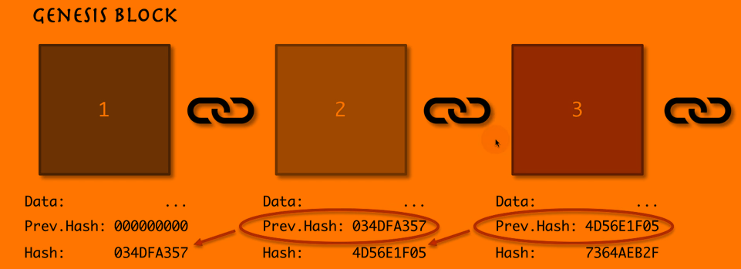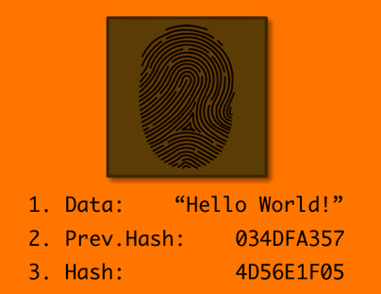Genesis block – the 1st block, stays first forever.

* Genesis Block
* Immutable Ledger
* Distributed P2P Network
* Nonce
* Mining
* SHA256
* Byzantine Fault Tolerance algorithm
* Consensus Protocol
  + PoW – Proof-of-Word
  + PoS – Proof-of-State
  1. Decentralized vs Distributed
* Centralization and decentralization refer to levels of control.

In a centralized system, control is exerted by just one entity (a person or an enterprise, for example). In a decentralized system, there is no single controlling entity. Instead, control is shared among several independent entities.

* Distribution refers to differences of location.

In a non-distributed (or co-located) system, all the parts of the system are in the same physical location. In a distributed system, parts of the system exist in separate locations.